ASSIGNMENT NO.2: Basic Data Retrieval using SQL

Student Name | Anushka Pachpute | Roll Number | 20971
Batch | SY. BSc Data Science | Topic | WB(Assignment-2)

Q1) Create a database named CollegeDB and a table named Student.

The table should contain the following columns:
Column Name | Data Type
StudentID | INT
StudentName | VARCHAR(50)
Age | INT
Course | VARCHAR(30)
City | VARCHAR(30)
Marks | INT
Add a primary key on StudentID and insert at least 10 records.
QUERY:

CREATE DATABASE CollegeDB;
USE CollegeDB;

CREATE TABLE Student (
StudentID INT PRIMARY KEY,
StudentName VARCHAR(50),
Age INT,
Course VARCHAR(30),
City VARCHAR(30),
Marks INT
);

INSERT INTO Student (StudentID, StudentName, Age, Course, City, Marks) VALUES
(1, 'Alice', 20, 'BSc', 'Mumbai', 85),
(2, 'Bob', 21, 'BCA', 'Pune', 78),
(3, 'Charlie', 19, 'BSc', 'Delhi', 92),
(4, 'Diana', 22, 'MCA', 'Mumbai', 88),
(5, 'Eve', 20, 'BCA', 'Nashik', 74),
(6, 'Frank', 21, 'BSc', 'Mumbai', 65),
(7, 'Grace', 19, 'MCA', 'Pune', 95),
(8, 'Heidi', 22, 'BCA', 'Delhi', 81),
(9, 'Ivan', 20, 'BSc', 'Mumbai', 89),
(10, 'Judy', 21, 'MCA', 'Nashik', 76);

OUTPUT:
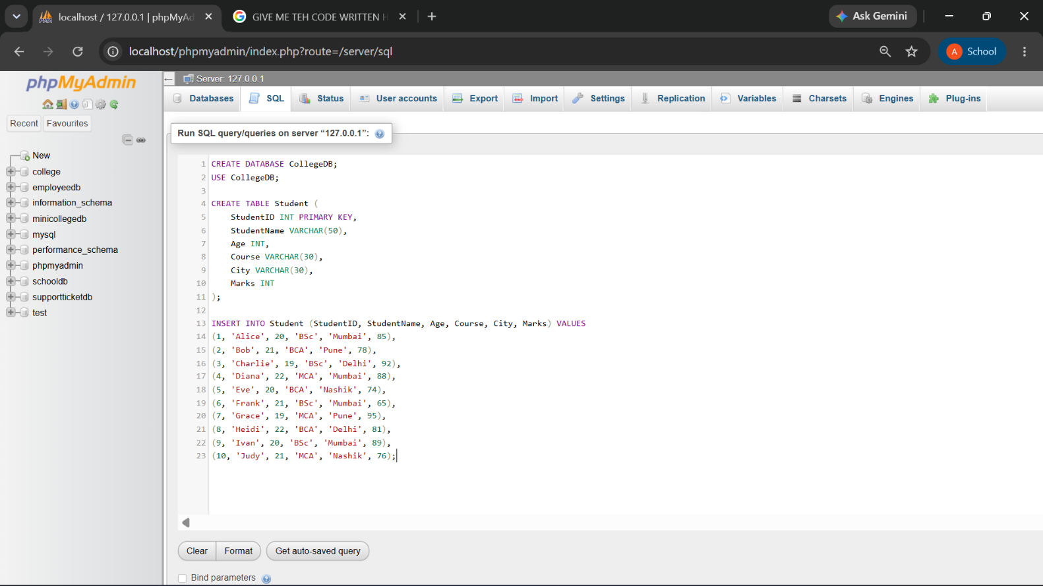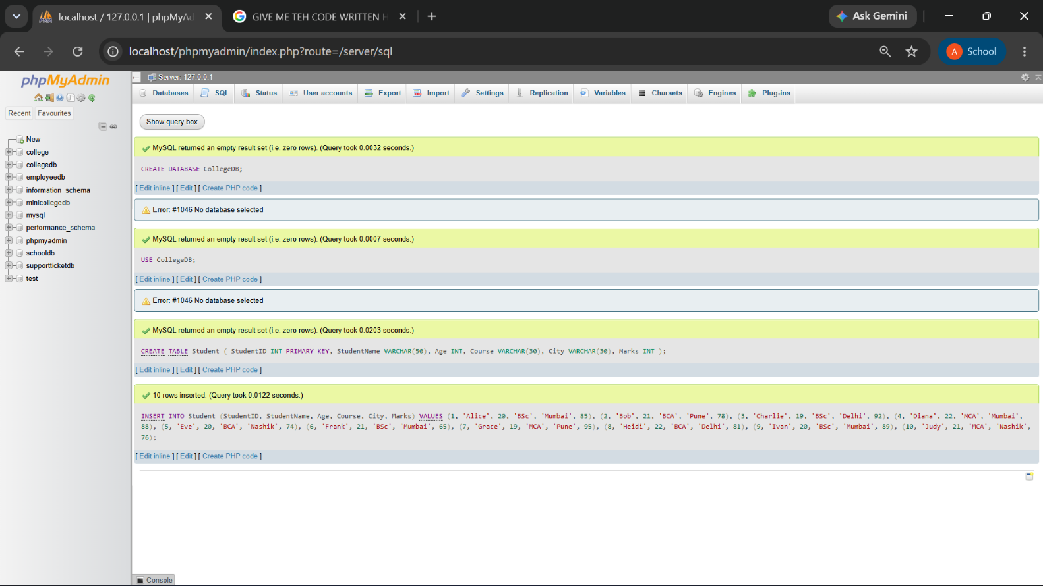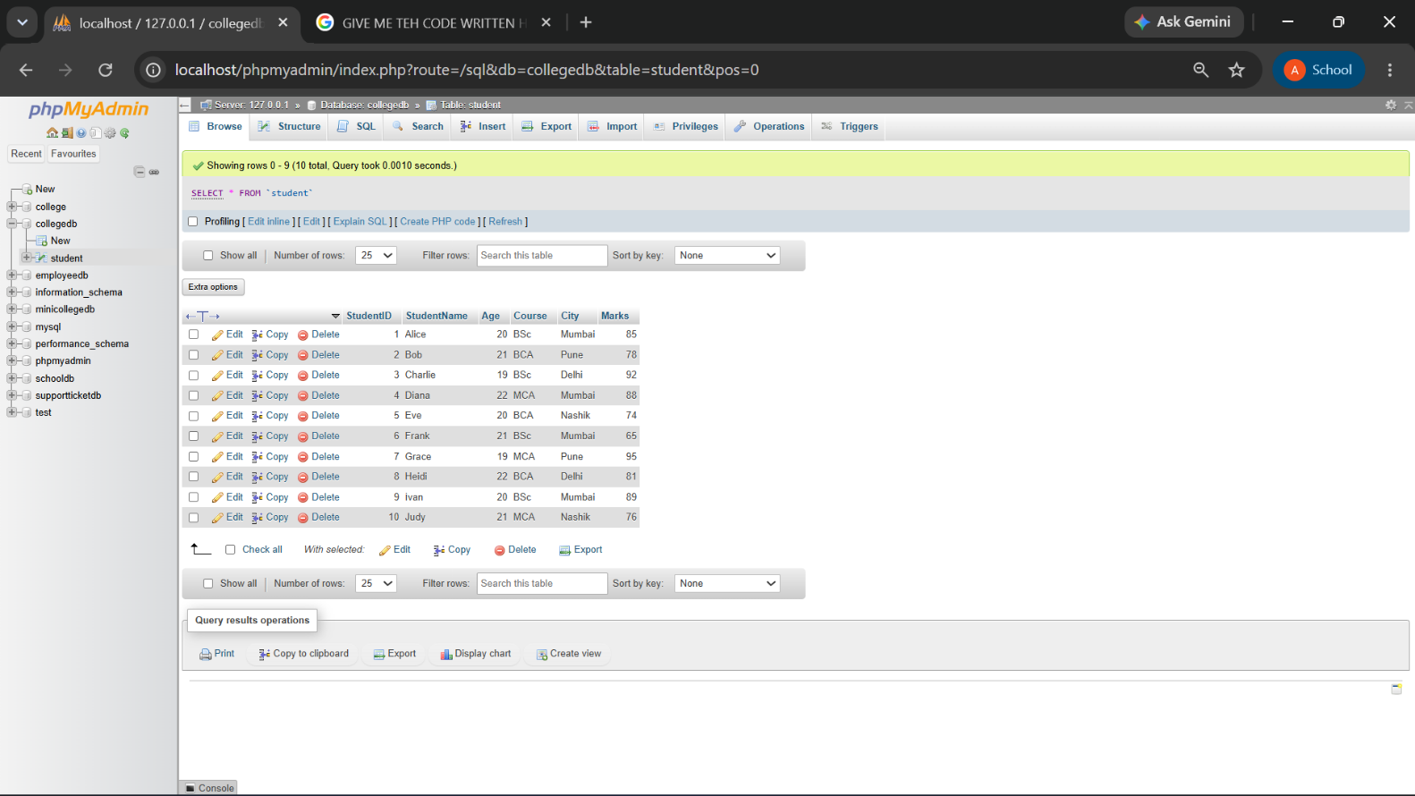

Q2) Write a MySQL query to display all records from the Student table.

The output should display all columns and all rows.

QUERY:
SELECT * FROM student;
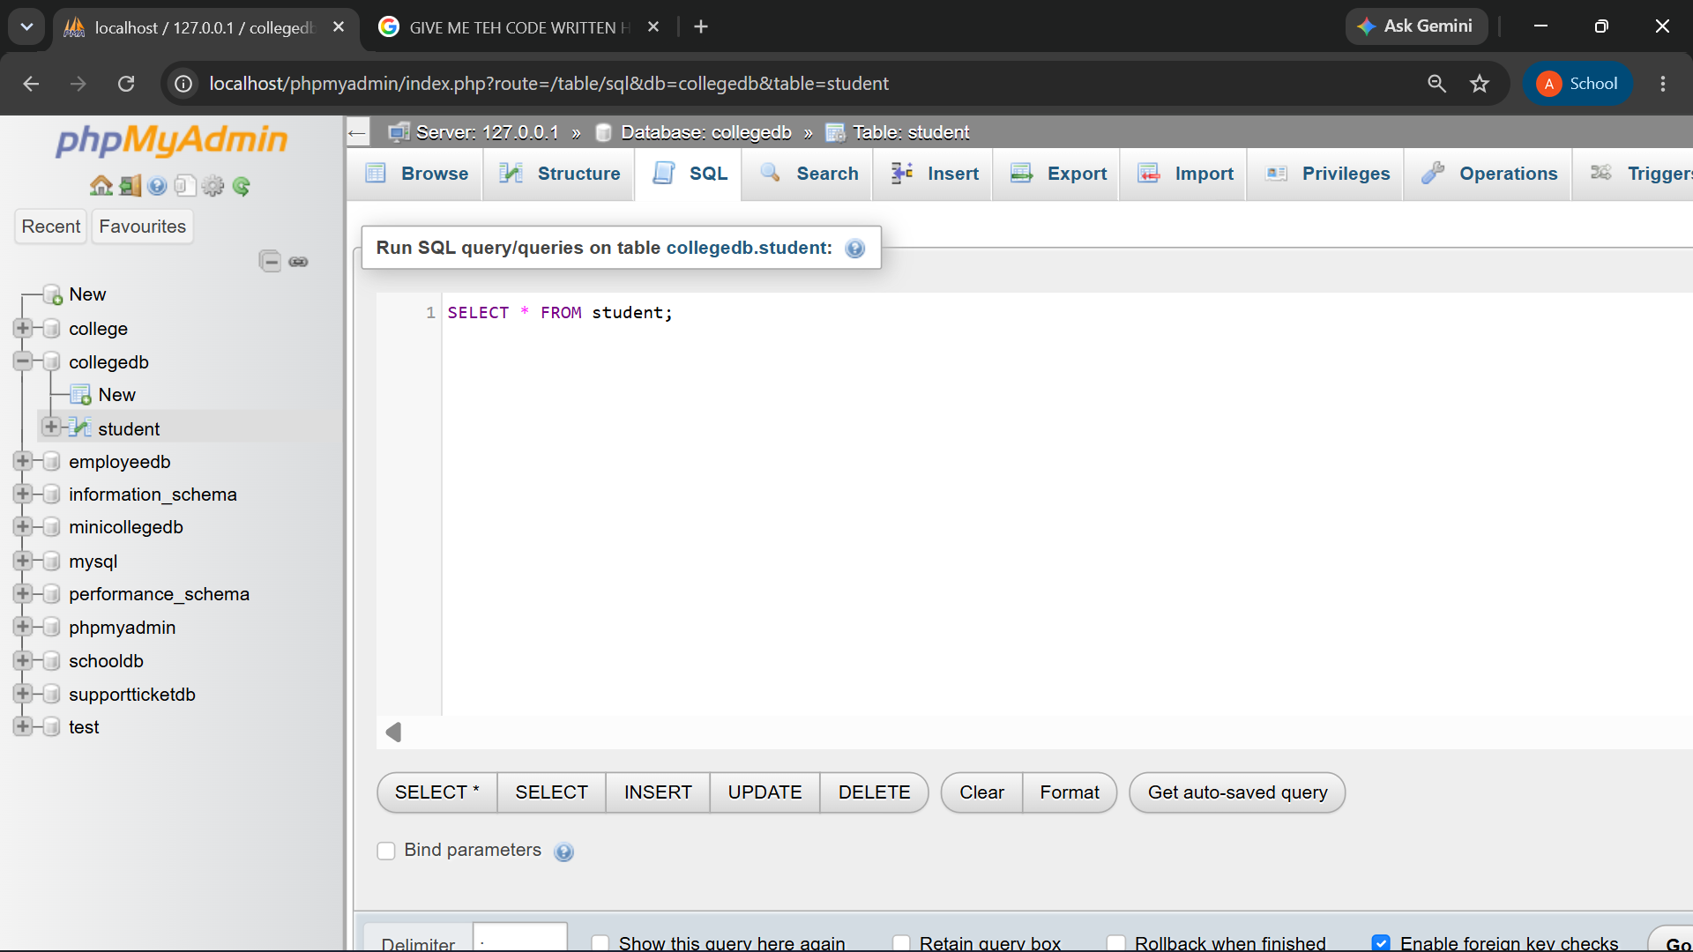
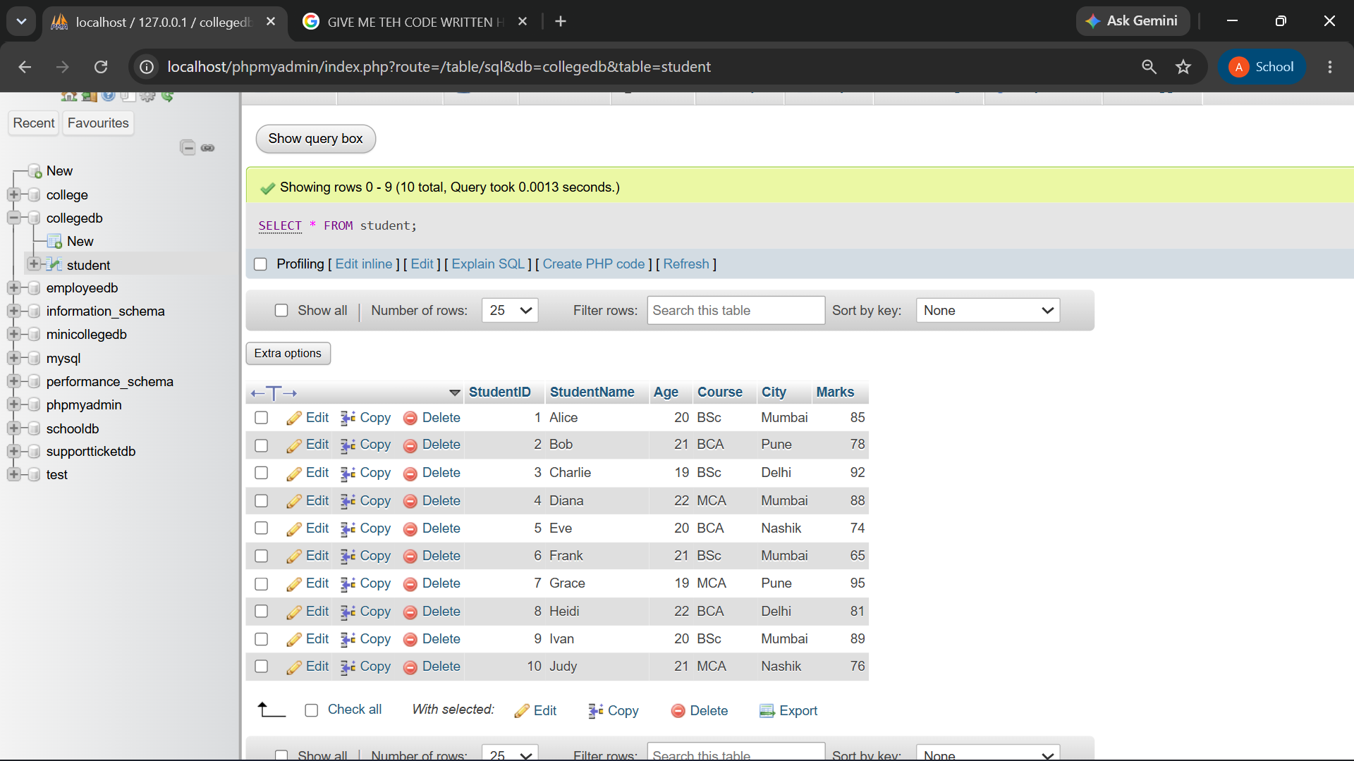

Q3) Write a MySQL query to display only the following columns:
- StudentName
- Course
- City

QUERY:
SELECT StudentName,Course,City FROM student;

OUTPUT:

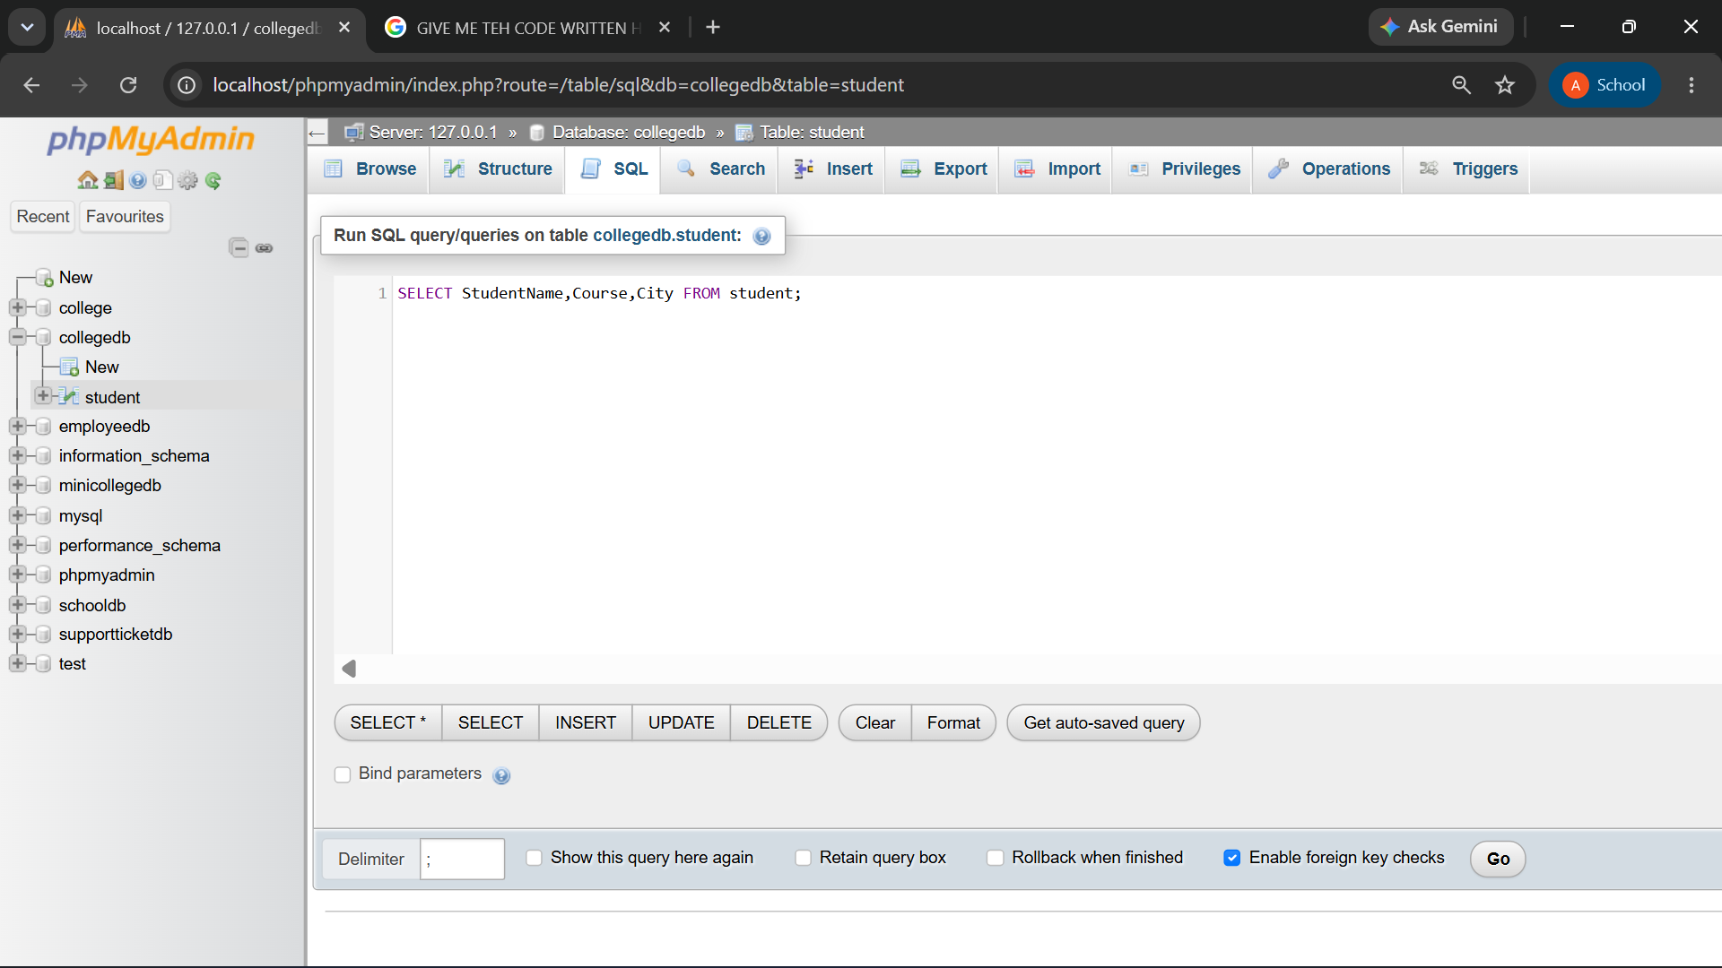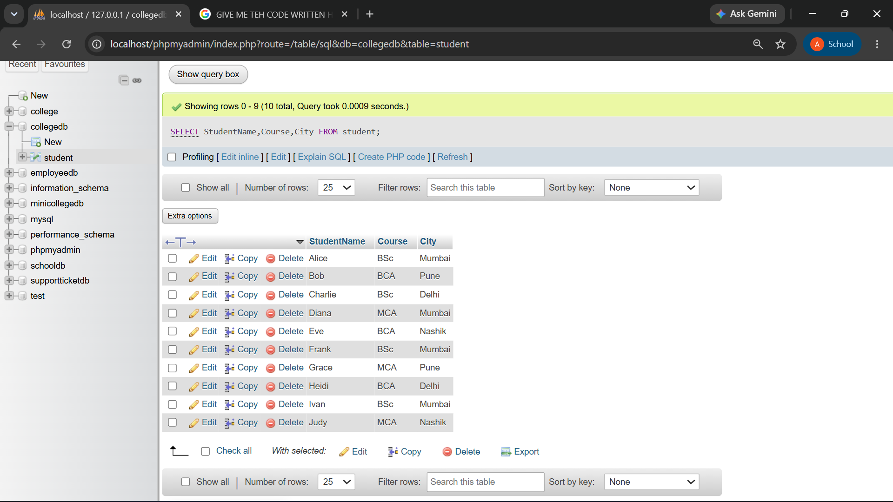

Q4) Write a MySQL query to display students who belong to the city Mumbai. The output should include:
- StudentID
- StudentName
- City
- Marks

QUERY:
SELECT StudentID,StudentName,City,Marks
FROM student
WHERE City = 'Mumbai';
OUTPUT:
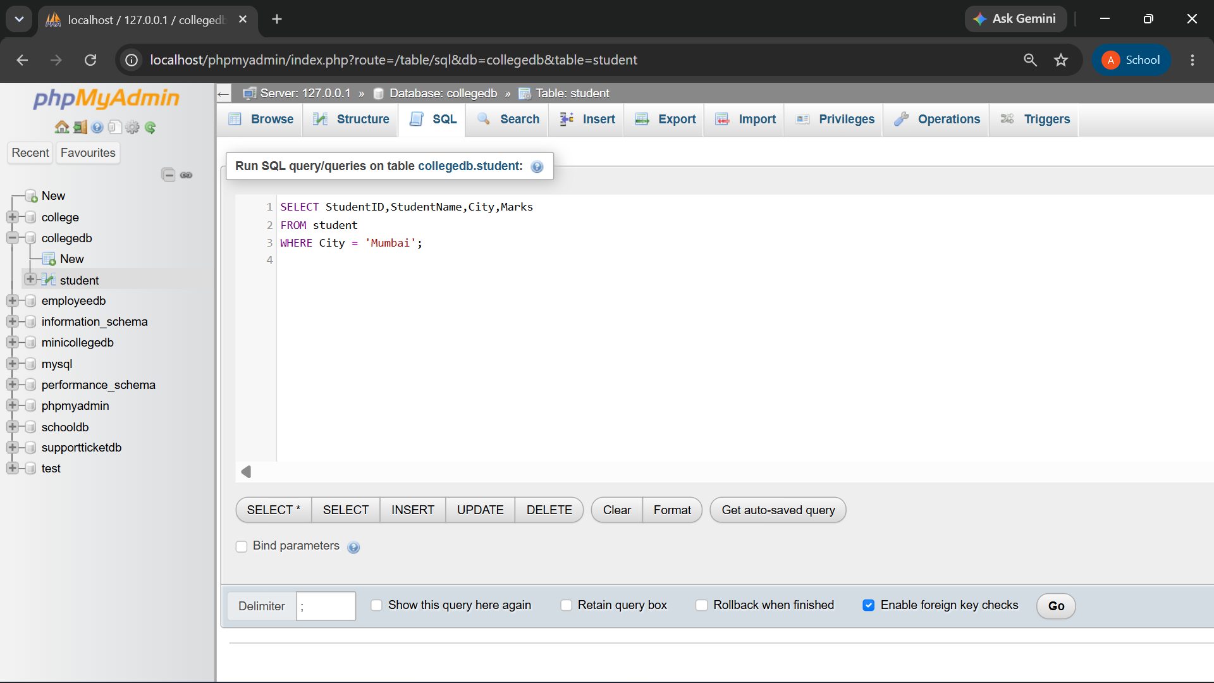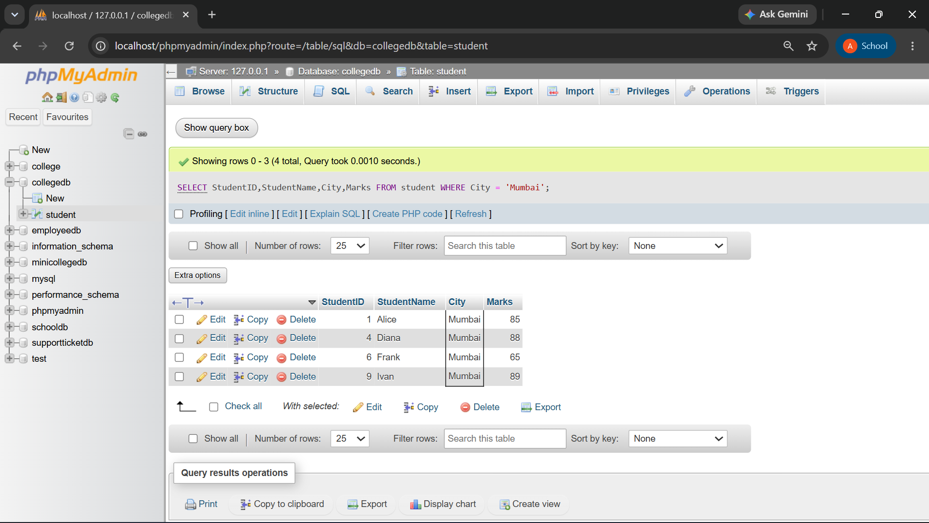

Q5) Write a MySQL query to display students whose marks are greater than 80.

The output should be sorted by marks in descending order.

QUERY:

SELECT * FROM student
WHERE Marks > 80
ORDER BY Marks DESC;
OUTPUT:
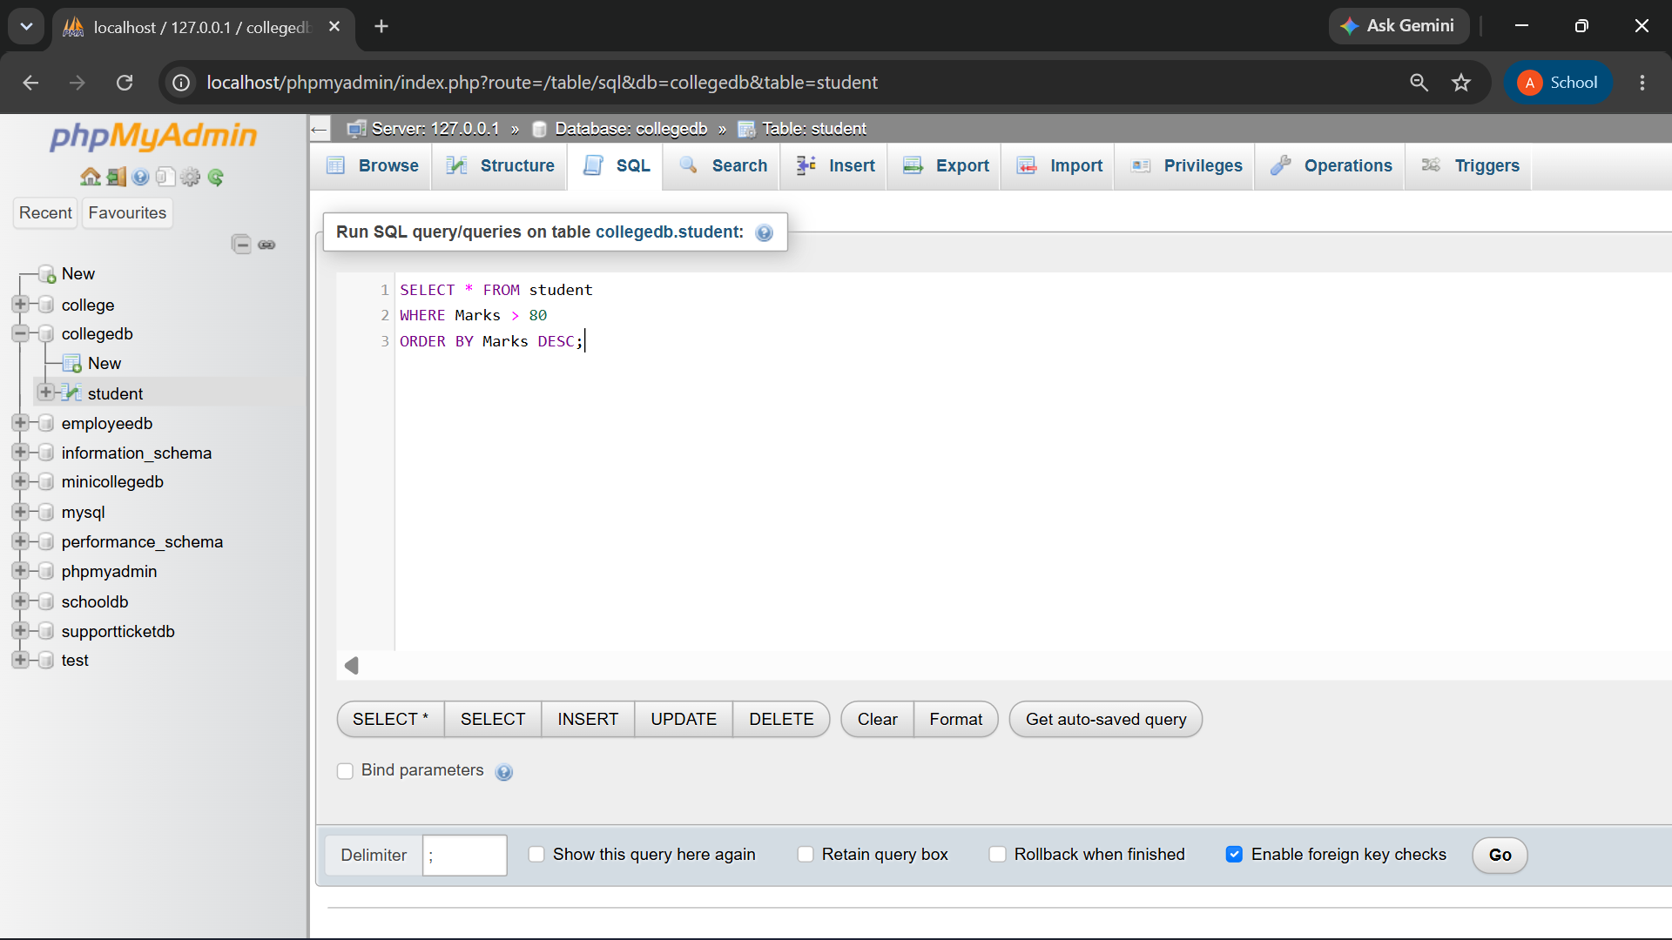

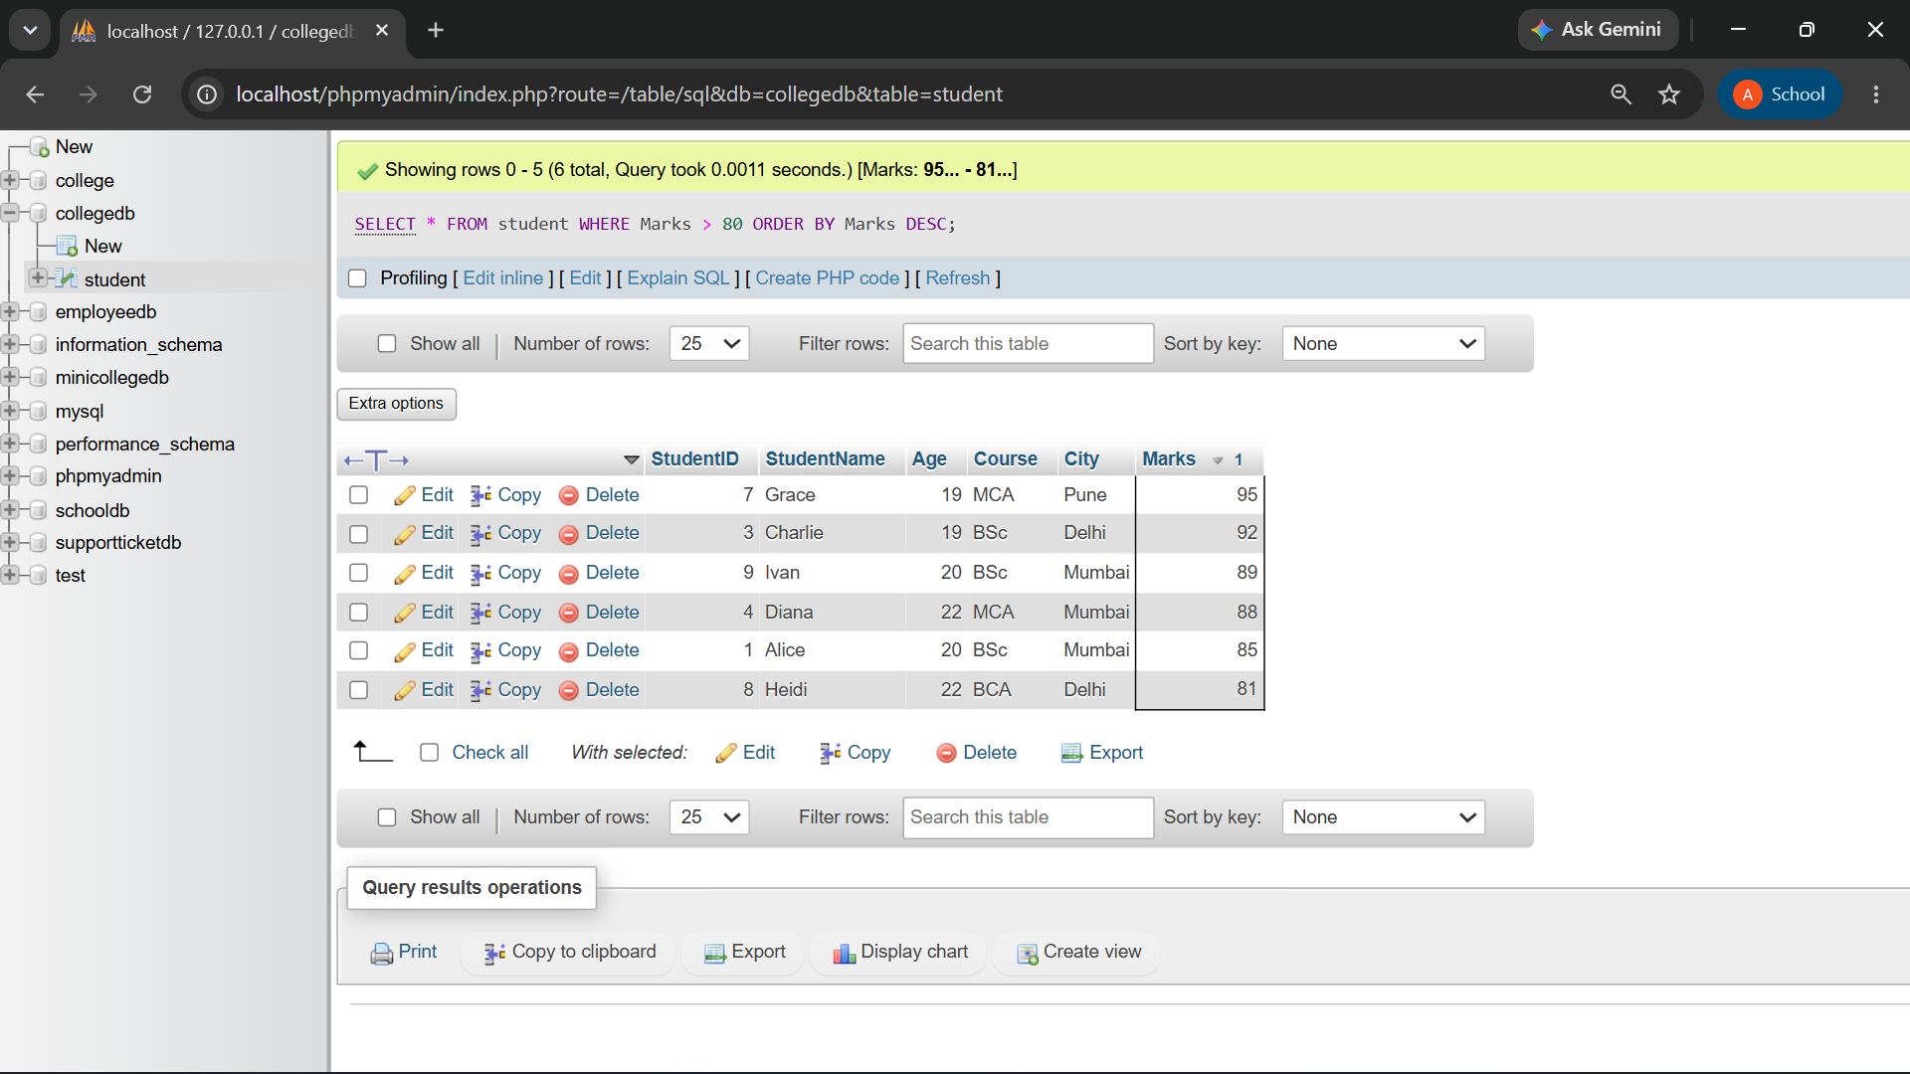

Q6) Write a MySQL query to display the top 3 students based on marks. The query should:
- Display StudentName and Marks.
- Sort marks from highest to lowest.
- Display only 3 records using LIMIT.

QUERY:
SELECT StudentName,Marks FROM student
ORDER by Marks DESC
LIMIT 3;

OUTPUT:
